**Coat of Arms Project**

[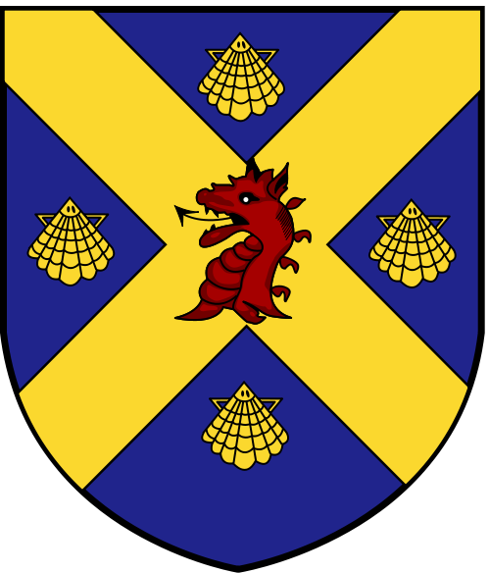](http://upload.wikimedia.org/wikipedia/commons/b/bb/Shield_of_Wade_Family_Coat_of_Arms.svg)

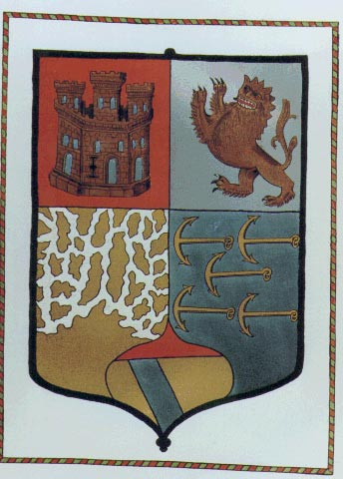

[](http://i.ehow.co.uk/images/a04/bg/g4/heraldry-shields-1.1-800X800.jpg)

Date Assigned: __________________ Date Due:_________________

A coat of arms is a design belonging to a particular person (or group of people) and used by him or her in a wide variety of ways. Coats of arms originated during the middle ages when knights used colors to make their armor and shield easily recognizable by friends, foes, and spectators in battle and tournament, almost like a uniform. The designs were worn over the armor, hence the term coat of arms. In addition to being painted on the shield, elements of the knight's coat of arms were used to decorate the helmet crest, the pavilion, and the banners of knights and lords. In the beginning, each knight chose his own symbols and designs. He might choose and animal to represent strength if he was strong, refer to an accomplishment, or to make a connection with his name. As time went on, the son would keep his father’s design and add his own elements to it. In this activity, you will design a coat of arms for yourself. Like the knights, you’ll want to make it tell something about who you are or what you like.



[](http://upload.wikimedia.org/wikipedia/commons/c/c2/Coat_of_Arms_Reagan_Shield_1.png)



**Step 1:** To make a coat of arms, start by working out a design on scratch paper, then make a larger shield from construction paper or poster board. There are no rules for how large it should be, but it should be NO SMALLER THAN a regular piece of paper, or 8 ½ by 11 inches.

**Step 2:** The most common shape for a shield was called a heater. Women, however, usually carried lozenges, which are shaped like a diamond, because they did not go into battle. You can choose either shape.



Heater Lozenge

**Step 3:** The surface of the shield is called the field. It can contain different symbols (called charges), colors (called tinctures), patterns (called furs), or designs. Each is symbolic of something, so be sure to pick things that represent you! You may choose symbols from the middle ages, or you may choose more modern images. Either way, be sure to attach a piece of paper that explains

what they mean!

**Step 4:** These shields were meant to be seen from a distance and clearly read. Make sure that you use contrasting colors and that you don’t overload the shield with shapes and patterns. Some basic rules are:

1. Limit the number of tinctures (metals, colors, or furs) to FOUR.

2. Limit the number of charges (elements like birds, animals, etc) to                between 1 and 4, with one being larger than the others.

3. Use good contrasting colors. (example: orange on yellow will not stand                out!)

4. Try to balance things out. (example: keep the same colors paired or                repeat an image)

* Refer to the Rubric as to how these will be graded!

Use the information on the attached sheets, as well as the list of symbols posted in class, to complete this assignment. Also, check the back page for some links to websites about heraldry.

**Step 5:** “**Explanation of My Shield**.” In this written essay you will need to list each tincture, charge, furs, ordinaries, and/or Cadency images or symbols of birth order you use. You will identify how these were once used throughout history (what they represent) and how these symbolize you and/your family.

**CHARGES** or SYMBOLS OR FIGURES USED TO DECORATE THE SHIELDS

Bear: strength Tower: strength, protection

Lion: courage Heart: loyalty, love

Swan: regal, splendid Sun: splendor

Stag: purity, strength of spirit Eagle: strength of mind

Falcon: ruthless Leopard: wisdom, agility

Boars: invincible Griffin: valor, vigilance

MANY more posted on board in class or go to this website: <http://www.storyboardtoys.com/gallery/coat-of-arms-lesson-plan.htm>

Checkout this website to see (in color and detail) the following examples:

<http://www4.gcsd.k12.sc.us/education/page/download.php?fileinfo=Q29hdF9vZl9Bcm1zX1Byb2plY3QucGRmOjo6L3d3dy9zY2hvb2xzL3NjL3JlbW90ZS9pbWFnZXMvZG9jbWdyLzIzMzlmaWxlMTIzMzYucGRm>

**TINCTURES** or COLORS ON A SHIELD

Gold or Yellow - Generosity and elevation of the mind

Silver or White - Peace and sincerity

Red - Warrior or martyr; Military strength and magnanimity

Blue - Truth and loyalty

Green - Hope, joy, and loyalty in love

Black - Constancy or grief

Purple - Royal majesty, sovereignty, and justice

Orange - Worthy ambition

Maroon - Patient in battle, and yet victorious

**FURS** or DESIGNS ON A SHIELD

Ermine White with black spots: Valor, justice, and dignity

Erminois Gold with black spots: Valor, justice, and dignity

Ermines Black with white spots: Valor, justice, and dignity

Pean Black with gold spots: Valor, justice, and dignity

Vair Blue and white bell-shaped objects: Great wealth

**ORDINARIES** or SYMBOLIC LINES ON A SHIELD

Nebuly Line: Clouds or air

Wavy Line: Sea or water

Engrailed Line: Earth or land

Invected Line: Earth or land

Indented Line: Fire

Dancette Line: Water

Raguly Line: Difficulties that have been encountered

Embattled Line: Walls of a fortress or town (also, fire)

**CADENCY IMAGES** or SYMBOLS OF BIRTH ORDER

**CHARGE PATTERNS or POPULAR WAYS TO DIVIDE A SHEILD**

* Must go to website noted above to see or look at examples posted in classroom.

**Sites with more information about Heraldry**

<http://freepages.genealogy.rootsweb.com/~jkmacmul/heraldry/index.html>

<http://www.digiserve.com/heraldry/symbols.htm>

<http://en.wikipedia.org/wiki/Charge_%28heraldry%29>

<http://www.fleurdelis.com/meanings.htm>

<http://museum.worldwidesam.net/reenactment/en/heraldry/blazon.htm>

<http://www.modernheraldry.com/register.html>

**RUBRIC  
 Coat of Arms Project**

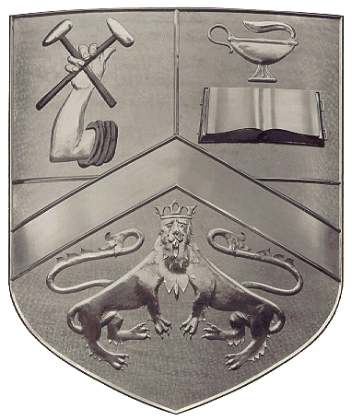

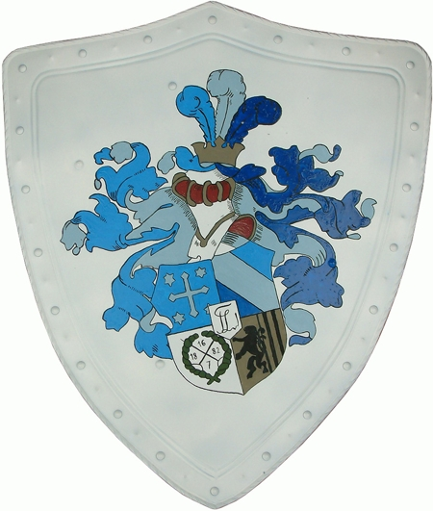

**SHIELD**

Use of Charge(s)(1 to 4/ 1 larger than others) ____/5

Use of Tincture(s) (1 to 4) ____/5

Use of Fur(s), Ordinaries, Cadency Images,   
and/or Symbols of Birth Order ____/5

Overall Appearance of Shield (neatness, detail, size, etc.) ____/10

**WRITTEN ESSAY: Explanation of My Shield**.

Listed each tincture, charge, furs,   
tinctures, and/or Cadency images   
or symbols of birth order you used ____/5

Identified how each of these were once used  
 throughout history (what they represent) ____/5

Described how these symbols, colors etc.  
 symbolize you and/your family. ____/15

**TOTAL _____/50**

Name ______________________________________

Comments: